高等学校校园铁人三项赛竞赛规则
The Rules of the Campus Triathlon
(2018年版)
(2018 version)
- 比赛装备
I. Competition Equipment
- Bicycle Motocross (BMX for short) is used in the race. The wheel diameter is 20 inches, which is suitable for BMX Racing on dirt track.
- BMX with rear brake and right hand brake will be provided by the organizing committee.
- No bells, bicycle support frame or other accessories on the car.
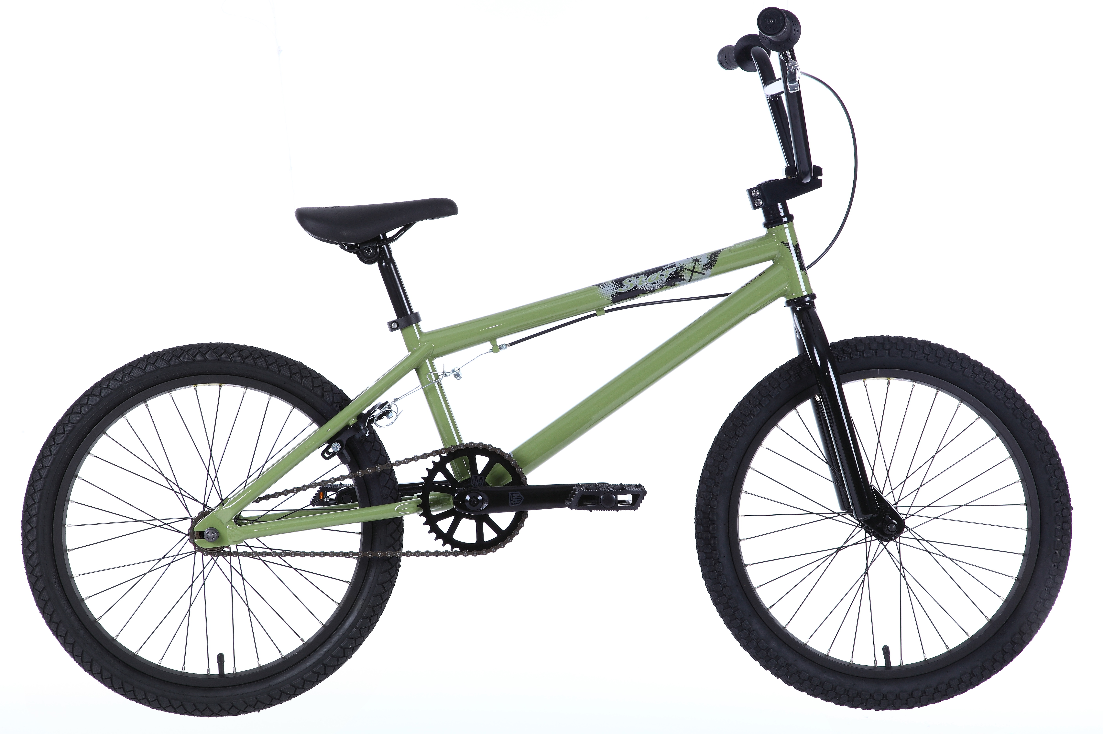
2. Roller skates (FIG. 6)
1) Non-racing inline skates are used in the competition.
2) The maximum diameter of wheels shall not exceed 110mm, and the total length of roller skates shall not exceed 50cm.
3) The wheel frame must be firmly fixed with the shoes and boots, and the axle must not protrude beyond the wheels.
4) No braking device is allowed.
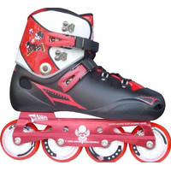 | 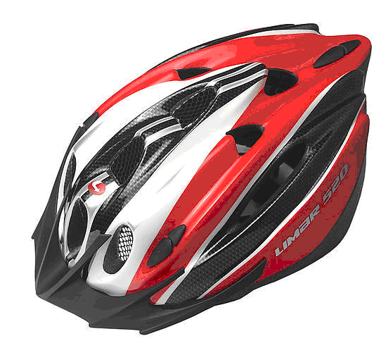 | 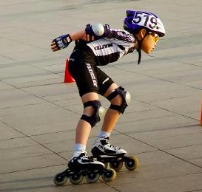
图6 轮滑鞋  FIG. 6 Roller skates | 图7 头盔  FIG. 7 helmet | 图8 轮滑护具  FIG. 8 Knee Guard
3. Helmet protection (FIG. 7-8)
- Helmets provided by the organizer (FIG. 7).
2) Modification of any part of the helmet, including safety clasp, outer fabric layer or removal of any part, is not allowed.
3) Athletes must wear helmets and protective gear in roller skating and BMX cycling (Figure 8). Protective gear and helmet must be taken off before starting running.
4) If the athlete needs to leave the track due to safety, disorientation, maintenance need or need to go to the washroom, he/she must remove the helmet after leaving the track. The helmet must be worn and the seat belt on the helmet must be fastened before re-entering the track.
4. Entry number
1) For both BMX and roller skating, the participants should wear two numbers on the front and back.
5. Illegal equipment
1) Artificial propulsion device;
2) Earphone;
3) Glass containers;
4) Mobile phones or other electronic communication equipment;
5) Other equipment not in accordance with the rules.
II. Departure regulations

1. Roller-skating start
1) Athletes should keep at least 50cm apart from each other at the starting line;
2) The starting line is 60cm away from the starting line, and the athlete must have at least one foot between the two lines. The initial movement direction of the roller skates must be consistent with the direction of the competition;
3) When starting out, the two roller skates must be in complete or partial contact with the ground, and the feet must not move and the body is allowed to swing;
4) The starter fires the gun as the starting signal. In case of the following circumstances, the starter may recall the athlete to restart the race:
A. If any athlete has started before the starting signal, all the athlets should start again. An athlete who starts before the signal once will be penalized. An athlete who starts before the signal twice will be disqualified.
B. If at the beginning of the race, one athlete within 50m falls, which causes the other athletes to fall continuously, all the athlets should start again.
2. Start running
1) After the starting gun goes off, the athlete starts. Athletes should not start ahead of the starting gun.
III. BMX Stage Regulation
1. During the race, athletes must ride along the right side of the track (FIG 7).
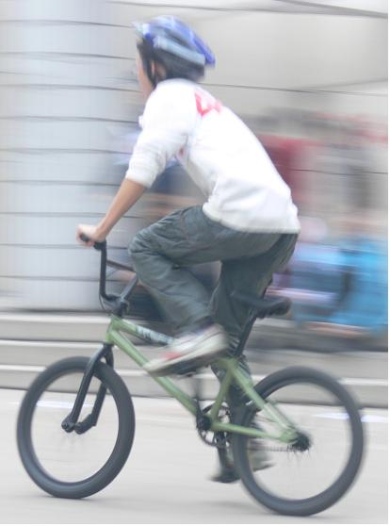 | 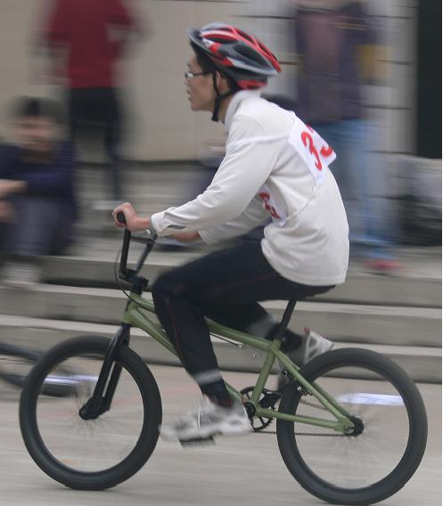
站立式骑行  Standing riding | 坐式骑行  Seated cycling
FIG. 7 Riding Posture
2. It is forbidden to follow other athletes during cycling
1) The athlete has the right to enter any position on the route under the condition of first entry and no physical contact with other athletes. When entering a new position, the athlete must leave a reasonable space for the normal route of the other athletes. There should be sufficient space for overtaking.
2) Athletes in the trailing area of other athletes have the obligation to avoid trailing.
3. Athletes are not allowed to bare the torso during the competition, otherwise the violator will be given a warning.
4. Athletes must compete in a safe manner. Any dangerous act that causes one or more athletes to fall will result in disqualification.
An athlete receiving any form of assistance other than from the referee during a competition will be penalized with a warning or disqualification.
6. Under no circumstances shall the athlete ride on a curve or in a horizontal direction. It is forbidden to pull, push, obstruct or assist other athletes to ride. Failure to do so will result in a warning or disqualification.
7. In the process of overtaking, it is not allowed to create obstacles for other athletes. The athlete who has been surpassed shall not hinder or assist other athletes.
8. Athletes who continue to compete after falling during the competition shall not accept help from others.
9. Athletes who withdraw from the competition automatically should inform the referee.
IV. Rules of Roller Skating Section
1. During the race, runners must slide along the left side of the track.
2. For other regulations of roller skating race, please refer to 3-9 regulations of BMX race.
V. Rules of the Running Stage
1. Runners may run or walk, not crawl or run barefoot. Otherwise, the runner will be disqualified.
2. Any athlete found to be a danger to himself or others will be expelled from the competition.
VI. Rules of Transfer Zone
- During the competition, only items needed for the competition are allowed to be placed in the transfer zone.
- In the transfer zone, the athletes shall not use the competition equipment of other athletes, but the equipment marked with their own number.
- The athlete must perform the change of BMX, roller skates and running in the specified area (transfer zone), or else the athlete will be punished with 10 seconds.
4. Athletes shall change their equipment in the following order within the stipulated area of the transfer zone, or they will be punished with a 10-second penalty.
1) Running → change of BMX: run to the transfer area (the area behind the red line), wear helmet/protective gear, wheel the BMX to the on-board line (the green line) and then ride to enter the BMX race.
2) BMX → Running change: get off the BMX in front of the red line, wheel the BMX to the transfer zone, drop the BMX, remove the helmet (protective gear), and enter the running section (the area behind the green line).
3) Roller skating → Running change: slide into the transfer zone (the area behind the red line), change the roller skates, take off the protective gear, take off the helmet, put on the running shoes, and enter the running section (the area behind the green line).
5. All personal equipment must be placed in its place within the transfer zone and must not be discarded on the play field or affected other players. Otherwise, the penalty will be 10 seconds.
6. The athletes shall not interfere with or block the route of other athletes in the transfer zone. Otherwise, the athletes will be given an oral warning or warning penalty or be disqualified.
7. Athletes are not allowed to stay in the transfer zone.

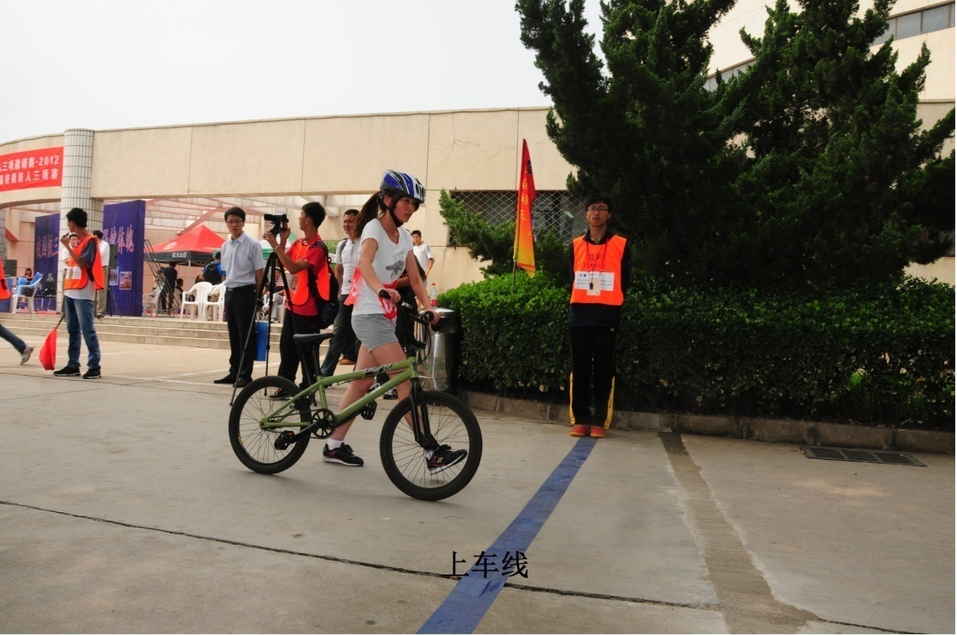 | 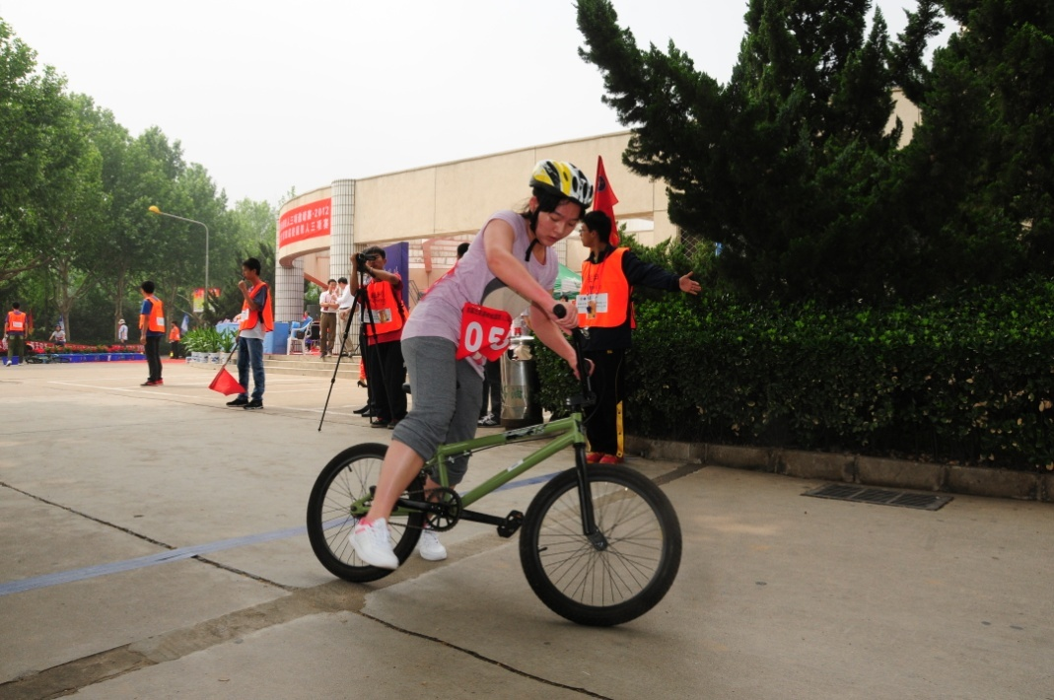
图11 推行至上车线 | 图12 推行至上车线后骑行
5.0m
1.0m米

图13 小轮车车尾随区

B
A

图14 尾随

