“Sinopec” Beijing Debate Open 2013

Dear Sir/Madam,

We would like to sincerely invite you to participate in the “Sinopec” Beijing Debate Open 2013 in China. This is the second Beijing Debate Open and we are aiming at creating one of the best international tournaments in Beijing. Participating in the BDO 2013, you will not only have the opportunity to meet excellent debaters from all over China, but also enjoy cultural and intellectual exchanges with International debaters and adjudicators that we have invited.

English debating helps university students in many ways. It consolidates students' presentation and persuasion skills. It enables students to have critical thinking and logical elaborations. It also encourages these future owners of the world to be actively concerned with their society, and the whole world.

China University of Petroleum (Beijing) is very proud to host this debate event from
March 22nd to 24th. We promise high quality adjudication, sincere hospitality and great social interactions for all of you.

The registration fee is 230RMB (without accommodations)/480 RMB (with accommodations) per person for Chinese teams and 80 USD (with accommodations and transportation subsidy) for International teams.

We look forward to seeing all of you in Beijing. For further information and questions, please contact BDO2013@163.com.

Yours sincerely,
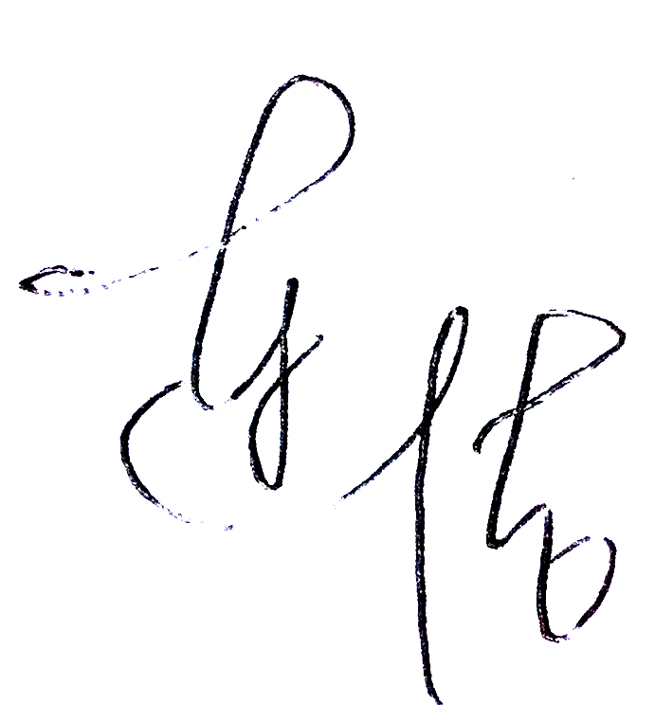
Lian Jie
Convener
“Sinopec” Beijing Debate Open 2013

尊敬的各位辩手与评委，

大家好！

中国石油大学（北京）诚邀您参加2013年“中国石化杯”北京英语辩论公开赛（“Sinopec” Beijing Debate Open 2013）。本次比赛是第二届北京英语辩论公开赛，我们致力于将它办成北京地区具有影响力的国际性辩论比赛，让辩手获得最有价值的辩论与学习体验。

比赛将于3月22日至24日在我校举行。国内队伍参赛注册费为￥230/人（含两日自助午餐晚餐、不含住宿），￥480/人（含两日食宿）；国际队伍参赛注册费为$80/人（含食宿并给予交通补助）。

衷心感谢您对本次比赛的支持和参与！若有任何问题请联系 BDO2013@163.com 。

中国石油大学（北京）
“中国石化杯”北京英语辩论公开赛组会
连洁

